ELISTAT PROJECT
Arricchire la vita degli anziani con l’Arteterapia
2020-1-TR01-KA227-ADU-097696

Risorse Utili E Riferimenti
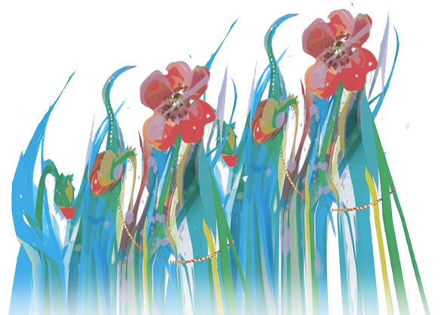
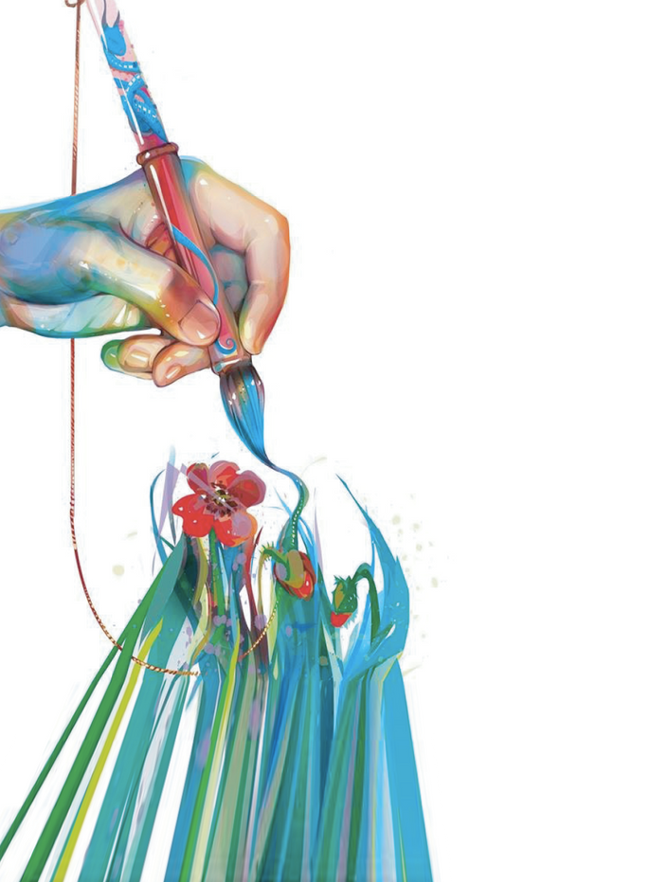

CEITIL, Mário (2010). Tendências de evolução da Formação Profissional. Revista Formar. Nº 71. pp. 41-42
PACHECO, José Augusto (2011). Discursos e lugares das competências em contextos de educação e formação. Coleção Panorama. Porto Editora
FERREIRA, Paulo da Trindade (2007). Guia do Animador na Formação de Adultos. Coleção Pontos de Referência. Editorial Presença
HARGIE, Owen (2011). Skilled interpersonal communication: research, theory and practice. 5th edition. London and New York: Routledge
LOPES, L. e PEREIRA, M. (2004). Métodos e Técnicas Pedagógicas. Lisboa: Fundação para a Divulgação das Tecnologias da Informação
BÁRBARA, Luís (2009). Métodos e Técnicas Pedagógicas/Andragógicas. Edição FCA – Teto de Nuvens
GOUVEIA, João (2005). Manual de Avaliação da Formação. POEFDS, Centro de Recursos em Conhecimento.
https://www.casadeglietruschi.it/news/arteterapia-e-anziani-larte-del-benessere/
https://www.researchgate.net/publication/283901327_Dance_and_Aging_A_Critical_Review_of_Findings_in_Neuroscience
https://www.frontiersin.org/articles/10.3389/fpsyg.2021.635975/full
https://ebcj.mums.ac.ir/article_11286.html
https://journals.sagepub.com/doi/10.1177/0891988720901789

National Endowment for the arts, The arts and aging, building the science, National endowment for the Arts Office of research & Analysis, 2013

https://nexus.jefferson.edu/health/how-can-we-harness-new-applications-of-art-therapy/

Professor Sarah Harper, Dr Kate Hamblin, “This is living”, Oxford Institute of Ageing, University of Oxford
Anna Rita Coricciati e Sabrina Stinziani, Le immagini raccontano, 2011
Nuove Arti terapie, N. 18/2011
Case, Caroline and Tessa Dalley , "The art therapy room" (2014) in The Handbook of Art Therapy ed. Caroline Case and Tessa Dalley. accessed 01 july. 2022 , Routledge Handbooks Online: https://www.routledgehandbooks.com/doi/10.4324/9781315779799.ch3
Carr, Catherine & Feldtkeller, Barbara & Havsteen-Franklin, Dominik & Huet, Val & Karkou Vicky & Sandford Stephen (2018) Group Arts Therapies Manual. East London Foundation NHS Trust Queen Mary University of London. Accessed on 01 July 2022. https://www.elft.nhs.uk/sites/default/files/5.%20190131ERAManualv1-1.pdf
Danieli, Yafit & Snir, Sharon & Regev, Dafna & Adoni-Kroyanker, Michal. (2019). Suitability of the art therapy room and changes in outcome measures in the education system. International Journal of Art Therapy. 24. 1-8. 10.1080/17454832.2018.1564778. accessed 01 july 2022. https://www.researchgate.net/publication/330226776_Suitability_of_the_art_therapy_room_and_changes_in_outcome_measures_in_the_education_system
Lieban, Marian (2004). Art therapy for groups. A handbook of themes and exercises. Second edition. Brunner Routledge. Accessed on 01 July 2022. https://readpbn.com/pdf/Art-Therapy-for-Groups-Sample-Pages.pdf
Zubala, Ania & Kennel, Nicola & Kackett, Simon (2021). Art Therapy in the Digital World: An Integrative Review of Current Practice and Future Directions. In Frontiers of Psychology.Accessed on 01 July 2022. https://doi.org/10.3389/fpsyg.2021.600070

